Bath and Wells Multi Academy Trust

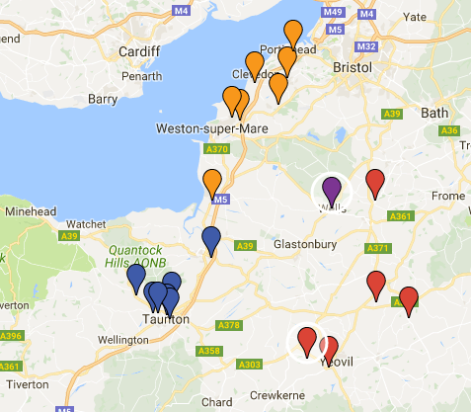

  - We work in 3 Hubs, Taunton (Blue), North Somerset (Orange) and South Somerset (Red) with a Central Team based in Wells (Purple)
  - Hubs are geographically based with a limit of 7-8 schools, all within a 30-40 minute drive from each other. This allows for easy travel between schools within a hub
  - Each Hub has a Leader (Paula Park, Head Teacher at All Saints is ours) who work for part of the week in his/her own school and the rest of the time support others in the Hub.
  - There is the potential to share staff training across hubs, resources, INSET, and even move staff between schools (this is voluntary; don’t panic you can’t be made to work in Portishead - not that it isn’t lovely there!).
  - Hubs are also encouraged to work with each other, again sharing resources, expertise etc.
  - There is a mantra that if one school is in difficulty, we are all in difficulty. With this collective mindset, it is the responsibility for all schools to help each other. Schools that are in a stronger position in terms of OFSTED are expected to offer support to those who are currently weaker. There is also a responsibility for the weaker schools to take up this support.
  - Each week the Hub Leaders meet with Teresa Wheeler (Director of Learning and Achievement) in Wells to share the progress, strengths next steps of the their Hub schools. This allows for difficulties to be spotted early and things put in place, and successes to be celebrated.
  - Each half term, the Heads from a Hub meet with their Hub leader to ensure that messages from the Central Team are being filtered down to schools, share school improvement projects, share resources etc.
  - Each term, all of the Heads from all three Hubs meet to share information about projects and processes that affect all school in the MAT.

