HORSINGTON CHURCH SCHOOL

HORSINGTON
TEMPLECOMBE
SOMERSET
BA8 0BW

Tel: (01963) 370358
Email: office@horsington.bwmat.org
Web Address: www.horsingtonbwmat.org

HEADTEACHER: Ian Rumbelow B.Ed (Dist) C.E.T.H.I.C.

19th June 2018

Dear Parent/Carer

Continuing Clarinet Lessons next term

We are currently trying to sort out our timetables for next year and have been asked to find out which children would like to continue having clarinet lessons in September.

The cost will be dependent on how many pupils take lessons, details of costings are given on the attached letter from Somerset Music. We think that with enough interested the large group lesson for 30mins a week would be a nice way to take this forward.

If your child is interested we would ask you to complete the tear off form on the Somerset Music letter and return it to the school office as soon as possible.

Yours sincerely


Ian Rumbelow
Headteacher





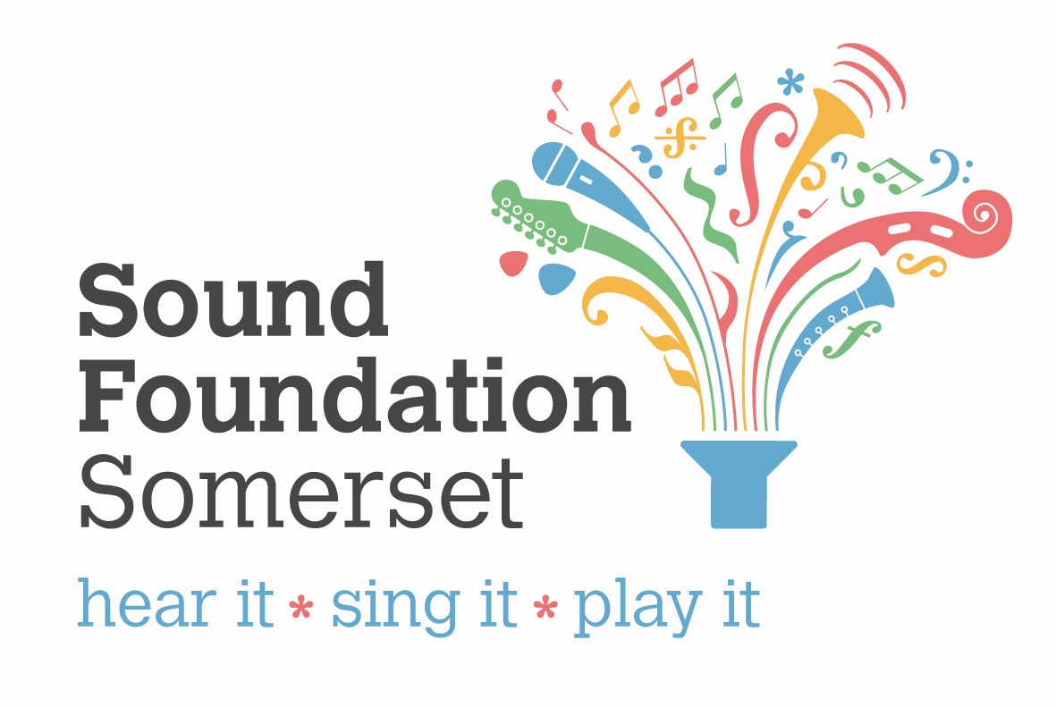
Dear Parent/Carer

As you are aware, your child is learning a musical instrument taught by a Somerset Music tutor. We hope that your child is enjoying these lessons and that it has opened a new opportunity for them to experience music making. You may be interested to know that as well as being fun, significant research has proven that learning an instrument at a young age improves a wide variety of skills such as learning skills, creative thinking, team working and problem solving as well as helping children build their self esteem.

We are offering the opportunity to each child to continue with their weekly tuition at school. This is usually in smaller group sizes and may be delivered before, during or after school, or in the lunch hour.

Instrument hire is free for the first year of learning and the cost of lessons is:

£14 per pupil 20min individual lesson
£21 per pupil 30min individual lesson
£7 per pupil 20min lesson (2 sharing)
£10.50 per pupil 30min lesson (2 sharing)

Large Group lessons are also available at £26.50 per 30mins. Large group lessons are for groups of four or more pupils and the cost is shared between the number of pupils in the group.

If your child is interested we would ask you to complete the tear off form below and return it to the school office 27th June 2018

Yours sincerely

Kirsten Wordley
Deputy Director
Somerset Music
somersetmusic@somerset.gov.uk

Somerset Music Tuition Continuation
I would like to register an interest in my child continuing with music tuition with Somerset Music next term.
Name of Child:___________________________________________________________

Name of parent/carer______________________Signature of parent/carer_____________

Lesson option _______________________________________________________________

Instrument type______________________________________________________________

